Pasang Nurbu Sherpa

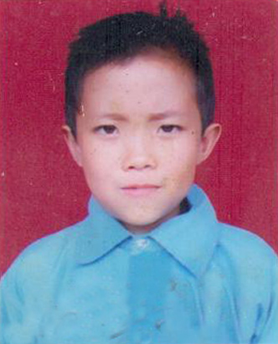
Pasang Nurbu Sherpa is a sudent of grade 6 in Himalayan Panchakanya Lower Secondary School. Pasang is very good student with a good learing skills and talent. He obtains a very good marks in his studies and has beacme favourite student of most of the teachers in his school.
Pasang has no parents since he was small. Having no parents, he stays with his uncle who also is week economically. He wants to gain knowledge and become educated, but the situation is not in his favor. From his childhood he went through many problems and obstacles. Though the situation are very difficult for him, he realised that education is most important in human life, with the same motivation from his loved uncle, he studies hard and secures very good marks in his studies. Not only in studies but he is also much more active in extra curricular activities. Having all these good skills and Knowledge, Pasang has aim to become an engineer and serve the nation.

